HTTP Assignment

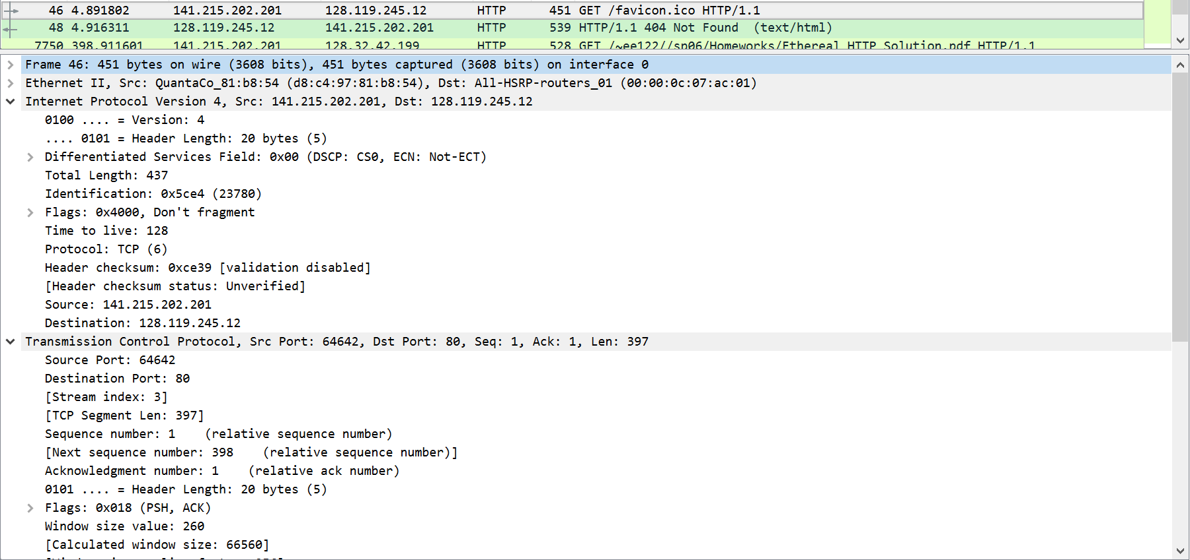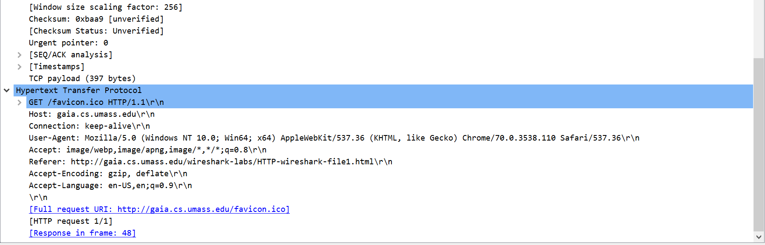

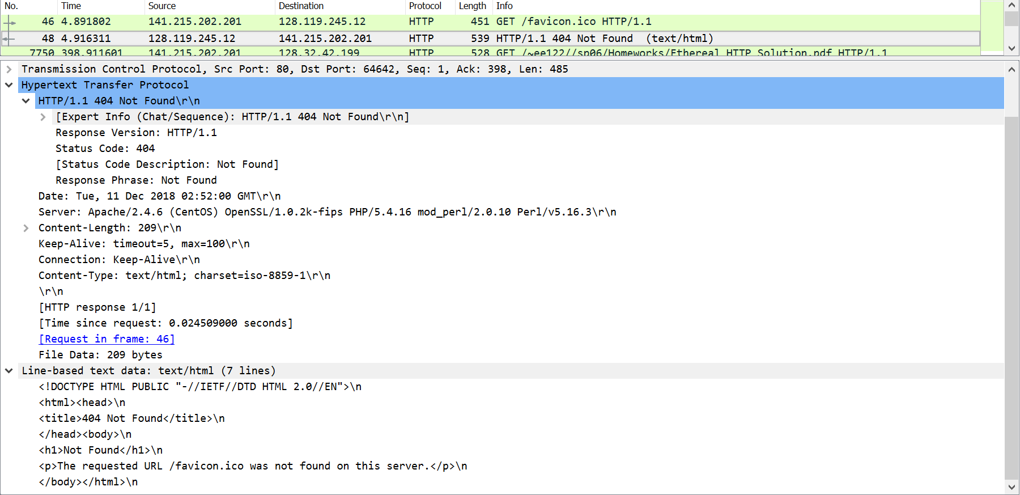

1. Both are using HTTP 1.1
2. Accept-Language: en-us
3. IP Address:
   1. IP address of gaia.cs.umass.edu is 128.119.245.12
   2. My local address is 141.215.202.201
4. Status Code:
   1. Status code returned to the browser is a 404.
5. The last modified time isn’t listed above, but the date recorded shows that it was Tue, 11 Dec 2018 02:52:00 GMT.
6. 209 bytes of content are being returned to the browser.
7. None, there are no more headers listed below.

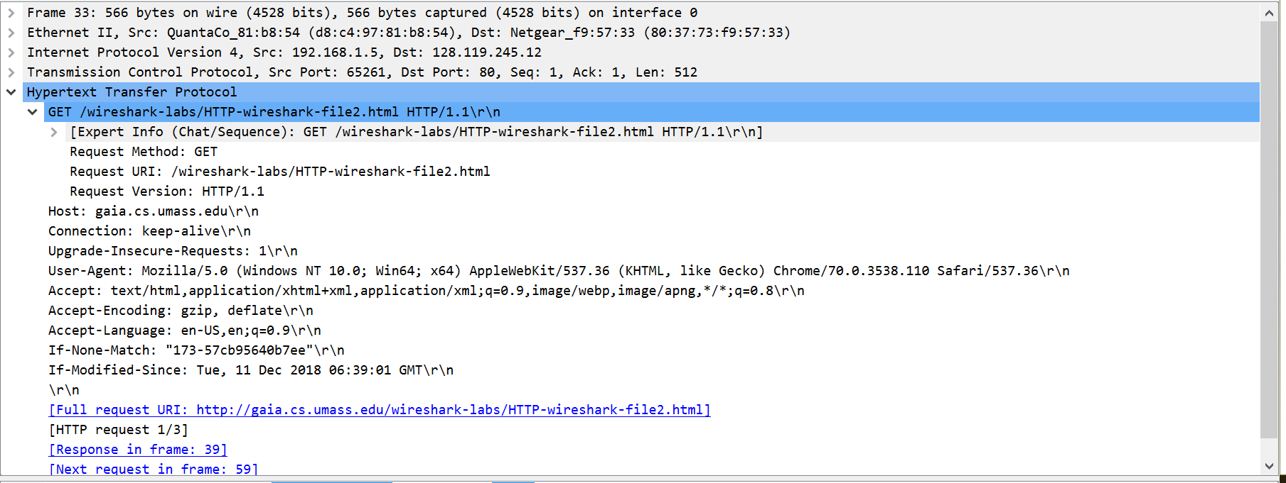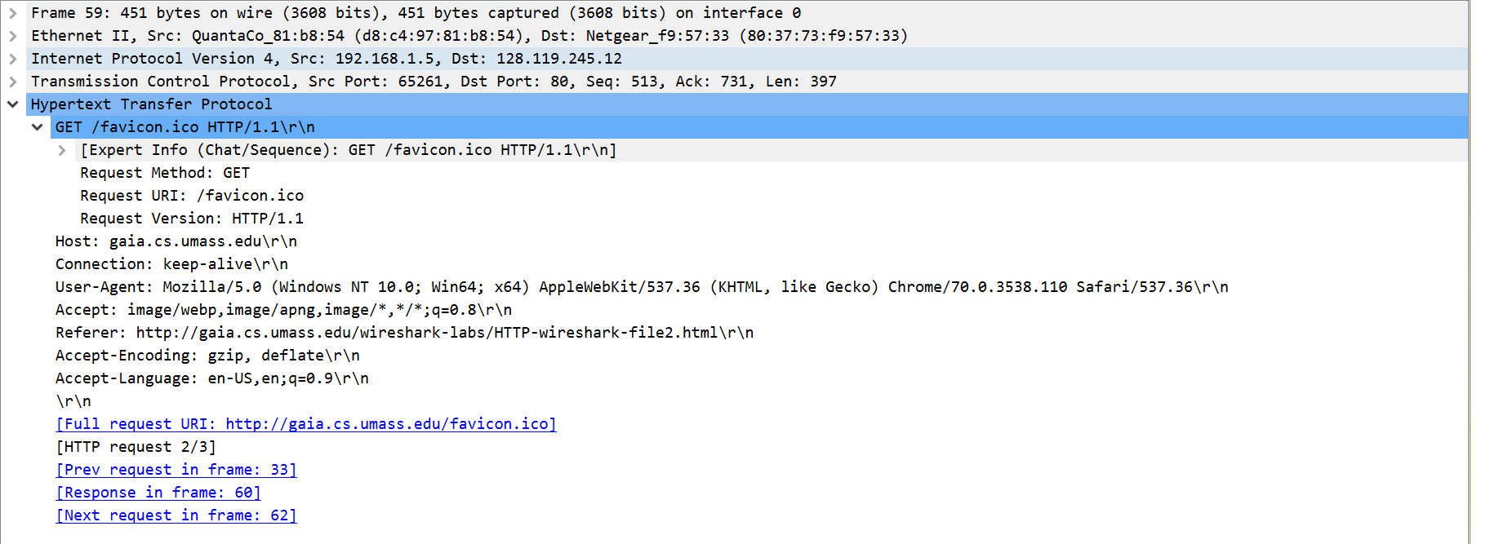

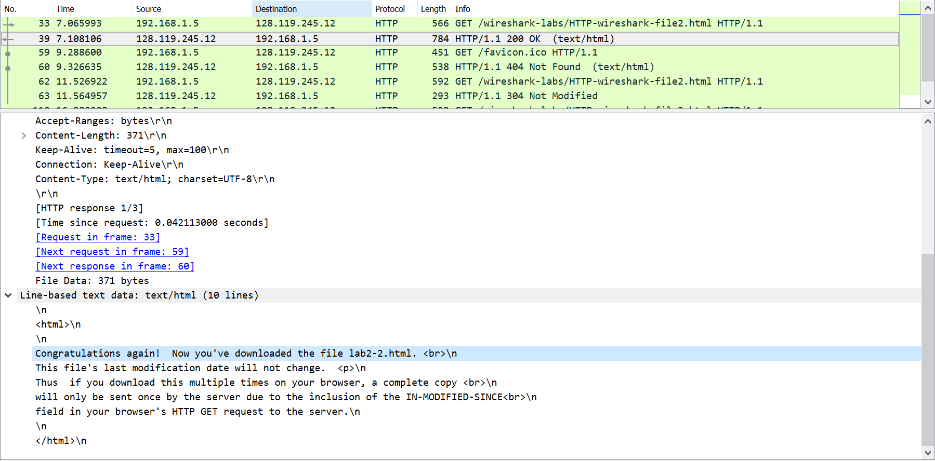

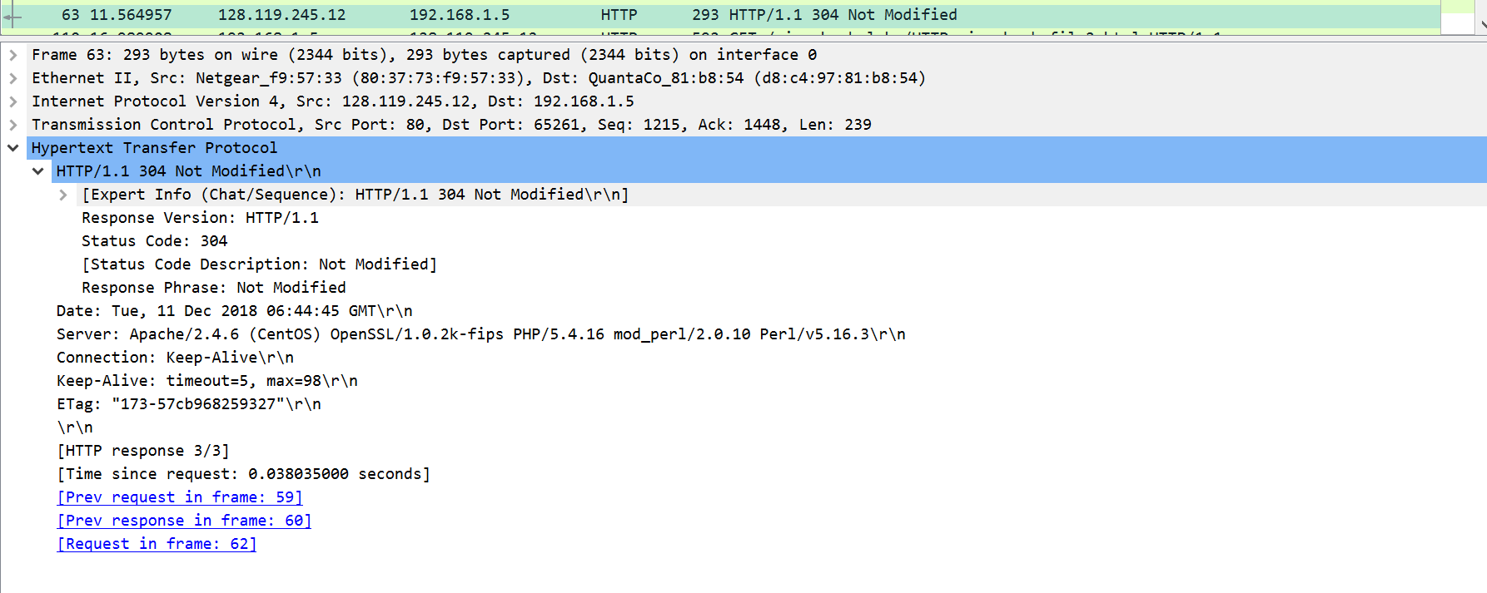

1. There’s a IF-MODIFIEDSINCE line in the first HTTP GET, but not the second.
2. In the 39 frame, the server explicitly returned contents, but it did not do that in the 63 frame.
3. An IF-MODIFIED-SINCE line is found in the first HTTP GET, but in the 63 frame, a 304 is returned and there is no modification.
4. In the 63 frame pic, the HTTP status code is 304 (Not Modified) so the server did not explicitly return any of the file’s contents. This is probably because the file was stored locally.

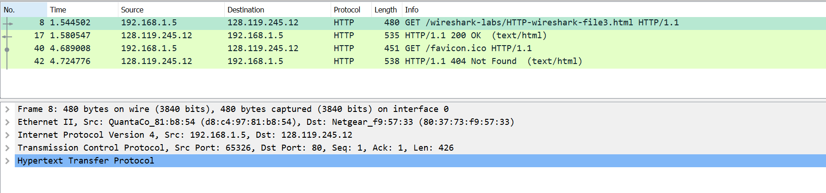

1. There were two HTTP GET requests sent by the browser. Packet number 8 contained the GET message for the Bill of Rights.

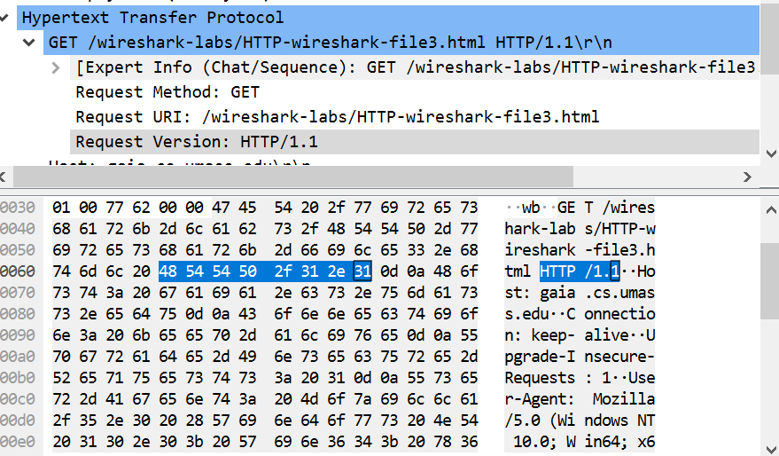

1. It connects in packet 10.
2. 200 OK
3. Three TCP segments (10, 11, 13) carried the HTTP response and the Bill of Rights.

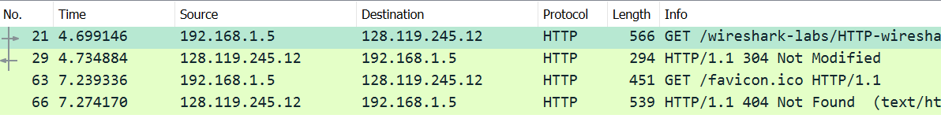

1. 2 HTTP GET requests were sent. Packet 21 was sent to 128.119.245.12, and packet 63 was sent to 128.119.245.12.
2. The images were downloaded in series. Packet 21s response packet was 29, and packet 63s response packet was 66. Based on the order, you can tell the first request was mad and completed long before the second request was made and completed.

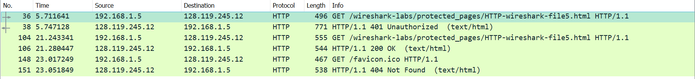

1. The initial HTTP GET was packet 36 and its response was packet 38 when it responded saying 401 Unauthorized.
2. The HTTP GET’s new included field is the Authorization: Basic